Site Certification – AutoPollen

Revision history
Version | Author/Editor | Description | Date
0.1 | Marie-Pierre Meurville | First final version put online | 01.05.2025
0.2 | Marie-Pierre Meurville | Translation of the online form into a Word form format for more flexibility. Voted on 09.10.2025, AutoPollen Annual Meeting, Cordoba. | 15.10.2025

This form collects all essential information for setting up or updating the Site Certification for your monitoring site(s), as outlined in the AutoPollen Site Certification Manual.
Before filling this form, make sure that your site fulfils the mandatory requirements described in section 5.5.2 of the Manual.
By completing each section, you will provide critical details about your site’s location, infrastructure, surrounding environment, sampling devices, and data management procedures. This information helps ensure consistency, facilitates accurate data interpretation, and supports long-term collaboration across all AutoPollen sites.
Note that all annex documents (maps, pictures etc) must be included in a zip file with this form and shared with the Evaluation Committee at the mail autopollen.sites@gmail.com. Filenames must be coherent with this form. Should the zip file be too large to be shared by email, data can be sent through a download link, at convenience.
Should you add comments or need more space, please join an annexe text document, referencing the section and question you would like to comment on.
e-mail address of the person filling this form | Click or tap here to enter text.
Date of submission | Click or tap to enter a date.
Date of the last submission  If this Site has been Certified before, indicate the last revision date. If this is the first submission, put today's date. | Click or tap to enter a date.

Basic Site Information
This section aims at gathering general information on the site location where the automatic bioaerosol monitoring devices are, and who is in charge of the site and measurements.
Institute / Organisation operating the site | Click or tap here to enter text.
Site Name and address | Click or tap here to enter text.
Contact person's name | Click or tap here to enter text.
Contact person's email | Click or tap here to enter text.
Site Coordinates (Latitude, Longitude) | Click or tap here to enter text.
Altitude (meters above sea level) | Click or tap here to enter text.

Maps of the surrounding land-use and vegetation
The site description must contain three maps of the surrounding area of the site. The maps must display three aspects:
- vegetation,
- altitude-elevation curves,
- land-use.
See section 5.5.2 of the AutoPollen Site Certification Manual for more details on what maps are expected.

Map of the immediate surroundings (within 100m of the site)  Indicate the document filename. | Click or tap here to enter text.
Notable Features within 100m  List buildings, gardens, abandoned areas, weather stations, or other features that could affect sampling. | Click or tap here to enter text.
Major Anthropological Particle Sources (within 100m)  List all relevant sources: heating chimneys, major roads, waste burning plants, big shopping centers etc. Indicate approximate heights and distance if possible. | Click or tap here to enter text.
Existence of large trees and crops (within 100 m)  Mention if any large wind-pollinated species or dense vegetation is located within 100m from the sampler. If possible, specify the species in the 100m buffer. Include any management info (e.g., regular pruning, farmland management). | Click or tap here to enter text.
Map of the adjacent surroundings (within 1km of the site)  Indicate the document filename. | Click or tap here to enter text.
Map of the distant surroundings (within 30 km of the site)  Indicate the document filename. | Click or tap here to enter text.
Site land use  Following EBAS guidelines (https://ebas-submit.nilu.no/templates/comments/sl_station_landuse) | Choose an item.
Future Land-Use Considerations  Is there any planned development in this area (urban growth, industrial sites) that might affect the station in the coming years? | Click or tap here to enter text.
Site setting  Following EBAS guidelines (https://ebas-submit.nilu.no/templates/comments/ss_station_setting) | Choose an item.
Site biogeographical zone  Following EBAS guidelines (www.eea.europa.eu/data-and-maps/figures/biogeographical-regions-in-europe-2) and according to Fig. 1. | Choose an item.

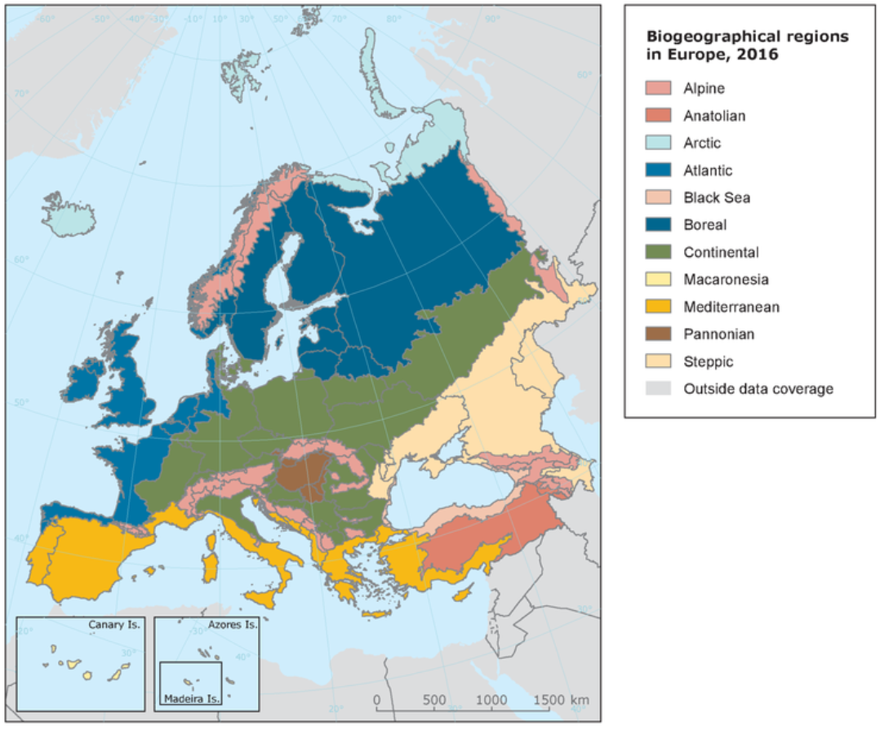
Figure 1: European biogeographical regions, 2016, European Environment Agency.

Microscale Location
How many automatic bioaerosol monitoring devices are there on the site?  Note that if devices are located more than 100m away from each other, a for must be filled per location. | Choose an item.

This section should be filled for each automatic bioaerosol monitoring device within 100m from each other (same site).
Fill only once for each device, leave any additional table blank.

First automatic device
Name / Code of the device | Click or tap here to enter text.
Model of the monitoring system | Click or tap here to enter text.
Location, whether on a flat roof or other, with details if the latter  Is the sampler placed on a flat rooftop, balcony, or mast? How many meters is it from the rooftop’s edge? | Click or tap here to enter text.
Height of the monitoring system’s location, in meters above the surrounding ground | Click or tap here to enter text.
Height of the inlet above the surface on which the instrument is located in meters  Indicate how high (in meters) above the roof the inlet is placed (recommended at least 1.5m). | Click or tap here to enter text.
Distance from other devices  If only one device, write NA | Click or tap here to enter text.
Number and type of obstacles at a distance of < 4 times the height of the obstacle from the device.  Indicate the approximate height of the object and the approximate distance to the sampler. | Click or tap here to enter text.
Number and type of obstacles at a distance of < 2 times the height of the obstacle from the device.  Indicate the approximate height of the object and the approximate distance to the sampler. | Click or tap here to enter text.
Pictures of the device location  Indicate the documents filenames. | Click or tap here to enter text.

Second automatic device
Name / Code of the device | Click or tap here to enter text.
Model of the monitoring system | Click or tap here to enter text.
Location, whether on a flat roof or other, with details if the latter  Is the sampler placed on a flat rooftop, balcony, or mast? How many meters is it from the rooftop’s edge? | Click or tap here to enter text.
Height of the monitoring system’s location, in meters above the surrounding ground | Click or tap here to enter text.
Height of the inlet above the surface on which the instrument is located in meters  Indicate how high (in meters) above the roof the inlet is placed (recommended at least 1.5m). | Click or tap here to enter text.
Distance from other devices  If only one device, write NA | Click or tap here to enter text.
Number and type of obstacles at a distance of < 4 times the height of the obstacle from the device.  Indicate the approximate height of the object and the approximate distance to the sampler. | Click or tap here to enter text.
Number and type of obstacles at a distance of < 2 times the height of the obstacle from the device.  Indicate the approximate height of the object and the approximate distance to the sampler. | Click or tap here to enter text.
Pictures of the device location  Indicate the documents filenames. | Click or tap here to enter text.

Third automatic device
Name / Code of the device | Click or tap here to enter text.
Model of the monitoring system | Click or tap here to enter text.
Location, whether on a flat roof or other, with details if the latter  Is the sampler placed on a flat rooftop, balcony, or mast? How many meters is it from the rooftop’s edge? | Click or tap here to enter text.
Height of the monitoring system’s location, in meters above the surrounding ground | Click or tap here to enter text.
Height of the inlet above the surface on which the instrument is located in meters  Indicate how high (in meters) above the roof the inlet is placed (recommended at least 1.5m). | Click or tap here to enter text.
Distance from other devices  If only one device, write NA | Click or tap here to enter text.
Number and type of obstacles at a distance of < 4 times the height of the obstacle from the device.  Indicate the approximate height of the object and the approximate distance to the sampler. | Click or tap here to enter text.
Number and type of obstacles at a distance of < 2 times the height of the obstacle from the device.  Indicate the approximate height of the object and the approximate distance to the sampler. | Click or tap here to enter text.
Pictures of the device location  Indicate the documents filenames. | Click or tap here to enter text.

Fourth automatic device
Name / Code of the device | Click or tap here to enter text.
Model of the monitoring system | Click or tap here to enter text.
Location, whether on a flat roof or other, with details if the latter  Is the sampler placed on a flat rooftop, balcony, or mast? How many meters is it from the rooftop’s edge? | Click or tap here to enter text.
Height of the monitoring system’s location, in meters above the surrounding ground | Click or tap here to enter text.
Height of the inlet above the surface on which the instrument is located in meters  Indicate how high (in meters) above the roof the inlet is placed (recommended at least 1.5m). | Click or tap here to enter text.
Distance from other devices  If only one device, write NA | Click or tap here to enter text.
Number and type of obstacles at a distance of < 4 times the height of the obstacle from the device.  Indicate the approximate height of the object and the approximate distance to the sampler. | Click or tap here to enter text.
Number and type of obstacles at a distance of < 2 times the height of the obstacle from the device.  Indicate the approximate height of the object and the approximate distance to the sampler. | Click or tap here to enter text.
Pictures of the device location  Indicate the documents filenames. | Click or tap here to enter text.

Fifth automatic device
Name / Code of the device | Click or tap here to enter text.
Model of the monitoring system | Click or tap here to enter text.
Location, whether on a flat roof or other, with details if the latter  Is the sampler placed on a flat rooftop, balcony, or mast? How many meters is it from the rooftop’s edge? | Click or tap here to enter text.
Height of the monitoring system’s location, in meters above the surrounding ground | Click or tap here to enter text.
Height of the inlet above the surface on which the instrument is located in meters  Indicate how high (in meters) above the roof the inlet is placed (recommended at least 1.5m). | Click or tap here to enter text.
Distance from other devices  If only one device, write NA | Click or tap here to enter text.
Number and type of obstacles at a distance of < 4 times the height of the obstacle from the device.  Indicate the approximate height of the object and the approximate distance to the sampler. | Click or tap here to enter text.
Number and type of obstacles at a distance of < 2 times the height of the obstacle from the device.  Indicate the approximate height of the object and the approximate distance to the sampler. | Click or tap here to enter text.
Pictures of the device location  Indicate the documents filenames. | Click or tap here to enter text.

Site accessibility and infrastructure
Accessibility  Describe how the device(s) is accessed (stairs, elevator, 24/7 availability, special permission needed, etc.). | Click or tap here to enter text.
Available Utilities  Check all that apply or provide details if needed. | ☐ Electricity (uninterrupted power supply)  ☐ Internet connection  ☐ Security measures (locks, fences, surveillance)  ☐ Government-owned building  Other: Click or tap here to enter text.
Site Stability  Is the site stable for long-term operation? Since what year has it been operational? Note any foreseen changes (e.g., building renovation). | Click or tap here to enter text.

Logbook
Indicate how the site logbook is maintained. Online e-logbook refers to a logbook following the standard format AutoPollen.

What format is the logbook? | Choose an item.
Please share the link to your e-logbook.  If not available, confirm that the logbook includes fixed fields:  - Site code (provided by EBAS during the data transfer setup, and national code) when available  - Location, country, latitude and longitude, altitude above sea level  - Contact person (email, phone number, address)  - The instrument model, manufacturer, device code (if available) and sampling flow  - The instrument altitude (above sea level, above ground, and above the surface where the device stands)  - The current algorithm version | Click or tap here to enter text.
Frequency of Logbook Updates  Minimum recommended is at least once per year or after significant events. | Click or tap here to enter text.

Data Gaps
This section is not mandatory, fill it with an estimation if you have the details.
Overall Data Capture (%)  Estimate the percentage of time the site successfully collects data (e.g., for hourly averages, at least 40 minutes of data must be valid). | Click or tap here to enter text.
Main causes of data gaps  List common malfunctions or interruptions (hardware failures, power outages, maintenance, etc.). | Click or tap here to enter text.

Data storage and availability
Data access protocol  Are level-1 data private, open to the public, or partially restricted? Provide any necessary links or instructions to request access. | Click or tap here to enter text.
Are data sent to EBAS or another database?  If data are available on a database, include the URL or reference, when possible. | Click or tap here to enter text.

Please provide an example NASA-Ames file. Explanations and template script and files can be found on the AutoPollen website . Note that if your data are not being sent to EBAS yet, there are informations, such as the Station code, that you cannot fill. In that case, let them blank, and the AutoPollen Site Evaluation Committee will come back to you.
Name of the template NASA-ames file: Click or tap here to enter text.

Historical weather information + Air quality
Existence of Historical Time Series  Has this site operated historically with automatic or manual methods (e.g., Hirst samplers)? | ☐ Yes  ☐ No
Historical Data Details  If yes, specify the taxa, time span, resolution, algorithms, and whether raw data are stored. Please specify if the data are collected with automatic devices or with traditional samplers. | Click or tap here to enter text.
Parallel Hirst Time Series  Is there a parallel manual sampling with a Hirst-type sampler on the site? Provide details (open data, protocol followed, time period covered, and for how long the manual sampling is planned to be done) | Click or tap here to enter text.
On-site weather station  Is there a meteorological station on the same site? | ☐ Yes  ☐ No
Nearest Official Meteorological Station  Provide the name and distance of the closest official station. | Click or tap here to enter text.
Weather Time Series Available  Describe any available weather data: coverage period, variables, frequency, etc. | Click or tap here to enter text.
Local Air Quality Station  Is there a nearby air quality monitoring station? If yes, specify location and data available. | Click or tap here to enter text.

